14-APEX
14-APEX-B=black----14-APEX-R=red

BANANA TO PIN LEAD ADAPTER

This is an improved adapter that provides a more secure connection to convert “banana jack” patient leads to the Pin (0.080”) leads.

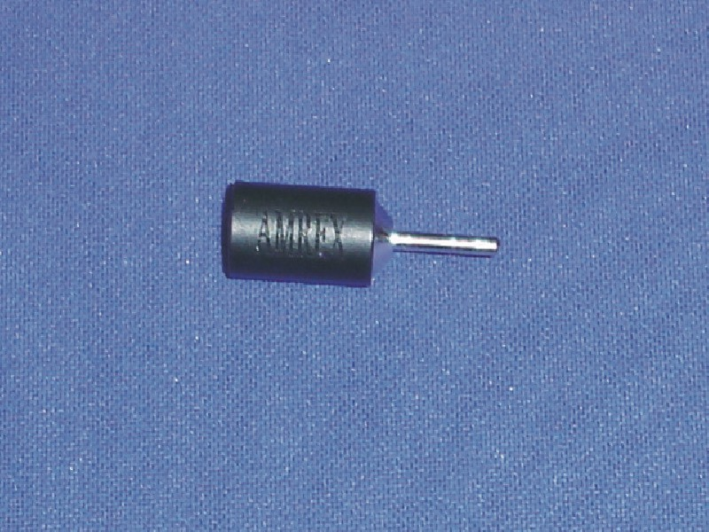

Instructions for use

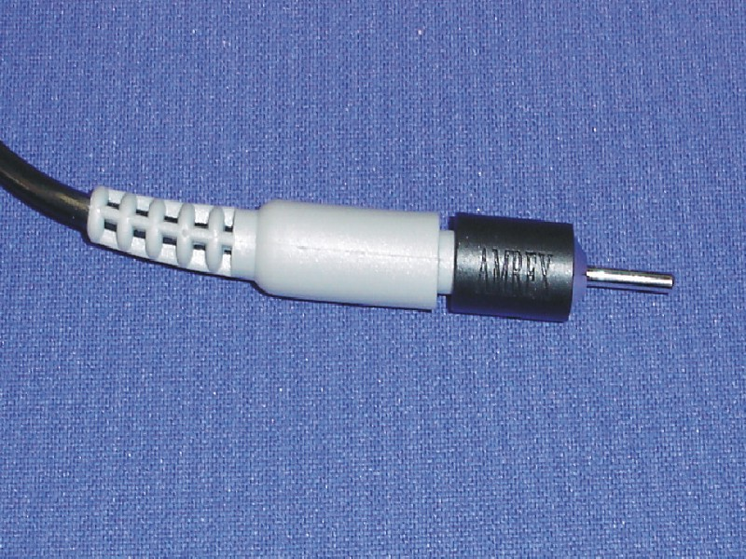

Push the Adapter onto the banana lead until it stops.

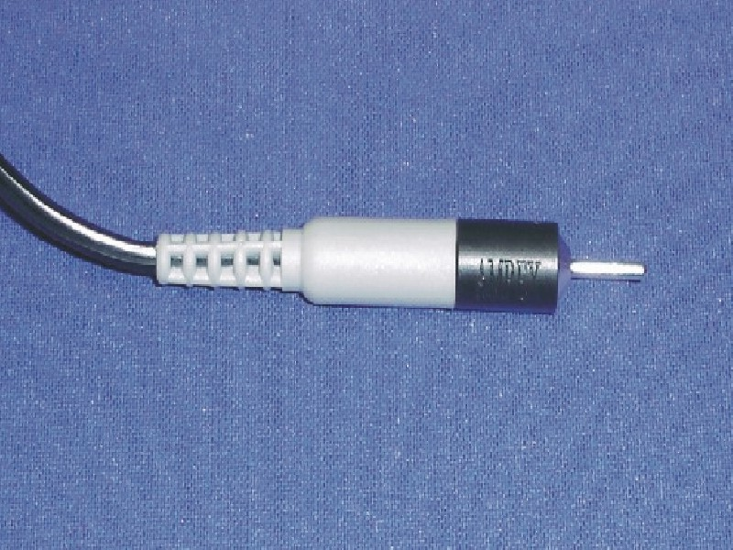

Rotate the adapter clockwise until it mates with the banana lead as shown. The adapter will be held securely onto the lead and is now ready for use.

Thank you for choosing Amrex products. www.AMREX-ZETRON.COM
If you have any questions, please call Amrex Technical Services
800-221-9069

